University of Notre Dame

MACHINE LEARNING FINAL PROJECT:
NFL PREDICTION MODEL

Professor Martin Barron
Due: November 24th, 2020
By: Nate Cull, Caspar Hu, Liam Kincaid, Ben Reutelshofer, and Kathleen Roe

Introduction
The problem we are faced with is trying to predict the outcome of NFL games using NFL season data from 2011-2020. The significance of this problem is rooted in the sports betting industry. As the betting industry continues to grow in both size and popularity, many people are attempting to predict the outcomes of NFL games, but struggle to consistently predict the winning team. This problem can be categorized as an interesting problem, and if this machine learning model can consistently predict accurate results, it could have a significant impact on the betting industry as well as oddsmakers. Aside from the sports betting motivation, we are all fans of the NFL and would be happy to have this prediction model for our own personal interests as well.
Abstract
Looking at the research problem outlined in the introduction above, we utilized NFL game data from 2019 and 2020 for our initial analysis, and then used NFL results data from the 2011-2020 seasons to build our prediction model. With our initial analysis, we provided some visualizations to compare team performance, as well as showed summary statistics of EPA (estimated points added) and WPA (win probability added) for offenses and defenses. We also visualized the relationships between run/pass plays and the EPA and WPA. After more visualizations, we ended our initial analysis with clustering, which will be further discussed later on. Moving to our prediction model: we used 2011-2018 results as our training data and 2019-2020 as our test data for our XGBoost model. After some tuning of the XGBoost model, we analyzed the importance of different variables on predicting game outcome and visualized these results. Our model results proved to be about 60% accurate with a sensitivity of around 82%.
Related Work
This problem has been analyzed previously by many sports blogs, websites, and researchers with the hopes of building a prediction model that can consistently predict NFL games. One of the most notable models was constructed in 2003 by Joshua Kahn, where he built a neural network to predict upcoming NFL games. Khan collected season averages for total yardage differential, rushing yardage differential, time of possession differential, turnover differential, and home vs. away team. After building the neural network, Khan used the model to predict the games for weeks 14 and 15 of the 2003 season and ended up with a 75% accuracy. As time has gone on, various advanced statistics such as win-probability-added (WPA) and estimated-points-added (EPA) have become available, which enable us to build on past machine learning models that have attempted to predict NFL outcomes. Our goal for this project was to improve on machine learning models such as Khan’s by utilizing more advanced statistics such as EPA and WPA.
Data Description
In order to complete our analysis, we used two data sets. The first dataset we used was scraped from the ‘nflfastR’ package which has play-by-play information of NFL games. We used games from the 2019 and current 2020 regular season. For the 2019 data, there are over 45,000 observations and 315 variables included in the data. For 2020, there are over 25,000 observations and 315 variables included as well. The key variables we looked at were runs and passes per game, red zone statistics, average run and pass EPA (estimated points added), and average run and pass WPA (win probability added) for offense and defense. EPA and WPA are statistics that attempt to measure the true value of a play, as opposed to more common stats such as yards and attempts that are commonly used in more mainstream football analysis. The second dataset we utilized contained game results from 2011-2010 along with EPA and WPA statistics for both the home and away team in each game. The EPA and WPA statistics were the season averages for each team up to that point in the season. For example, if the game was played week 5, the EPA and WPA averages were the averages from the first 4 weeks of that season. To ensure that there was a winner in each game, all ties were filtered out so the model could classify each game as either a win or a loss based on point differential.
Methods
Before building our model to predict the outcomes of NFL games, we used K-means clustering to group the teams in the 2019 season into clusters based on their EPA and WPA season averages. We started with four clusters, but the Baltimore Ravens were put in their own cluster due to their dominance in the 2019 regular season. So, we changed the cluster number to two and split the teams in the league in half. Analyzing the two clusters, the majority of teams in the first cluster made the playoffs and experienced success in the 2019 season whereas most of the teams in cluster two fared poorly in the 2019 season and did not win many games. Some advantages of K-means clustering are that it is easy to implement, scales to large datasets, and you can manually pick the number of clusters you want. Some weaknesses include struggling with a high number of variables and the method being sensitive to outliers. As we can see in our example, the Ravens were an outlier, and the model placed them in their own cluster.
To predict the outcomes for each NFL game, we decided to build an XG Boost Model. XGBoost is an efficient implementation of gradient boosting and can be used for regression as well as classification. For this type of machine learning model, the data must be in a matrix format instead of a dataframe. Thus, we converted our training and test datasets into matrices to ensure they were in the right format to feed into the model. When comparing which machine learning model would be most suitable for our problem and dataset, XGBoost Model has stronger prediction power than other machine learning models such as RandomForest or bagging. An additional benefit of XGBoost models is they are resilient to overfitting. One disadvantage or weakness of XGBoost models is the model is very slow to train. Thus, it takes much more time to train and tune the model compared to other machine learning models such as RandomForest or Bagging. Other weaknesses for XGBoost models are being sensitive to outliers, and being hard to run in parallel because the trees build in sequence. While we do not feel that outliers had much effect on the training of this specific model, this weakness could potentially have a major impact depending on the problem you are analyzing.
Results
Once deciding that a XGBoost Model was the best machine learning model to solve this problem, we partitioned the NFL game results from 2011-2020 into a training and test dataset. The training dataset included regular season games from 2011-2018, and the test dataset contained regular season games from 2019-2020. The response variable for our model was the score differential in each game. To classify the results, if the point differential was above zero, the home team won the game. If the point differential was below zero, the away team won the game. We felt that using the point differential as the response variable would provide more information than a binary variable describing if the home team won or lost. After running a naive XGBoost model, we tuned the minimum child weight, max depth, gamma, subsample, colsample, and eta hyper parameters to increase the accuracy of the prediction model. To tune these hyper parameters, we chose the value for each parameter with the lowest RMSE. After completing the tuning process, the hyper parameters for the final model were as follows; minimum child weight of 10, max depth of 3, gamma of .10, subsample of 0.7, colsample of 0.7, and an eta of .01. To judge the final XGBoost model, the metrics we primarily focused on were accuracy followed by sensitivity. Looking at the metrics for the final model, the model accuracy was 60.65% and the sensitivity was 82.81%. Comparing these numbers to the naive model, the accuracy increased by .27% and the sensitivity increased by 4.16% following the tuning process.
Discussion
To analyze which variables in our model were the most significant in determining point differential, we created a SHAP value graph. SHAP value graphs are much more informative than standard model importance plots because they visualize the direction and relationship between the EPA and WPA statistics and the point differential. After analyzing the SHAP value graph, we can conclude that if the away team has a high defensive run frequency value, the point differential is likely to swing more positively and in favor of the home team. This makes sense because if the home team is running frequently against the defense, they are probably winning the game and trying to run out the remaining time. Also, if the home team has more passes per game in the red zone, the score differential is likely to be higher in favor of the home team. This makes sense because if the home team is in the red zone a lot, they are likely going to score a lot of points and increase the point differential.
Looking at our model, one insight is WPA and EPA statistics have a huge impact on winning and losing in the NFL. If a team wants to maintain success or improve on last season, their focus should be on improving the efficiency of their run and pass offense. When looking at the visualizations in the appendix, the teams with the most success had an efficient passing and running offense. It does not matter the frequency of passes or runs in a game, but rather how efficient the team is when they choose to either pass or run. From a betting perspective, this model could be used to help predict which teams are going to win each game. Average pass and run epa and wpa correlate to winning football games, so if you are going to bet on a team, it may be wise to look at how efficient they are before betting on them.
Conclusion and Future Work
In conclusion, we were able to build a model using EPA and WPA statistics that could predict the outcome of NFL games with over 60% accuracy. We realize that it is very difficult to consistently predict NFL games, and we are happy with obtaining this level of accuracy in such a short time span. However, there are many ways to improve and build upon our XGBoost Model. To more accurately predict the outcomes of NFL games, some variables that could be added to the XGBoost Model include weather information, home field advantage, miles traveled by the away team, injuries, coaching, and number of days since the team’s last game. These variables can play a major impact in the outcome of an NFL game and accounting for these factors would hopefully increase the performance and accuracy of the model.

Appendix
Visualization 1 - Win Probability Graph, Atlanta Falcons vs. Dallas Cowboys, Week 2, 2020
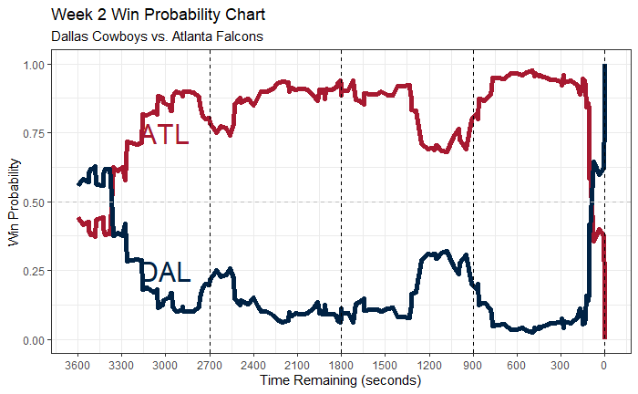
Visualization 2 - Average Run EPA vs. Runs per Game, 2019
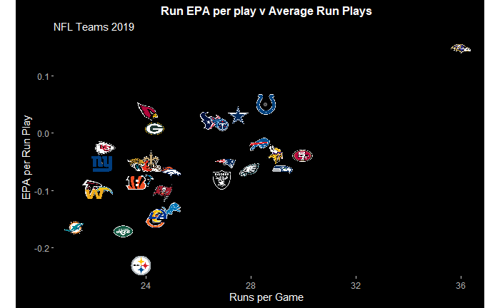
Visualization 3 - Average Pass EPA vs. Passes per Game
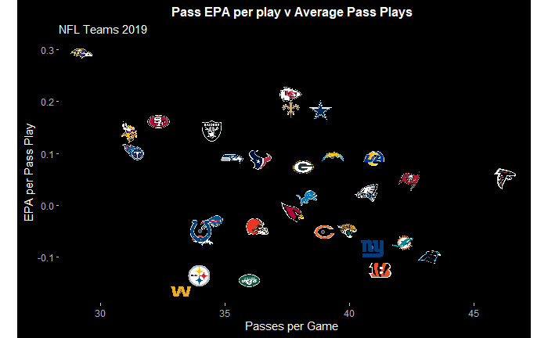
Visualization 4 - 2019 Offensive EPA vs. Defensive EPA Per Play
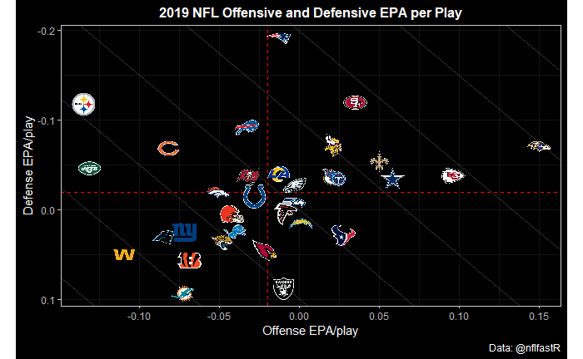
Visualization 5 - Team Efficiency Plot (Rush EPA vs. Pass EPA)
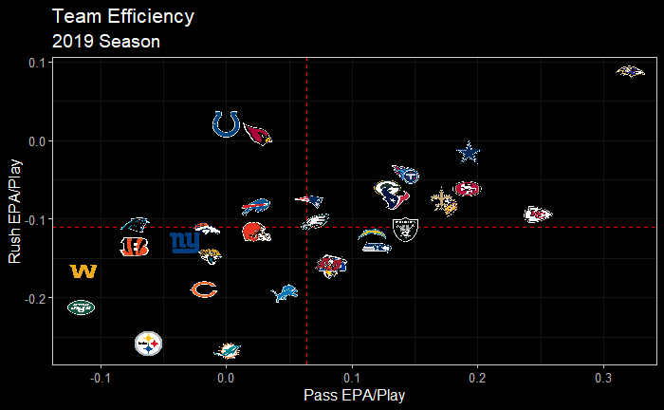

Visualization 6 - Model Feature Importance
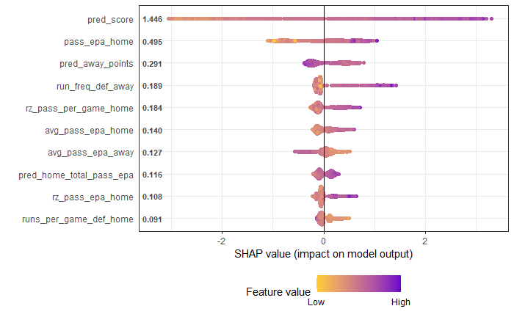
Contributions
Each team member contributed equally to each section of the short report. Instead of working on the different parts separately, our group met and attacked each category as a team. This allowed us to all be on the same page regarding the method we are going to use to attack this problem.
Bibliography
http://homepages.cae.wisc.edu/~ece539/project/f03/kahn.pdf Khan Neural Network
https://www.nflfastr.com/ Package for scraping NFL data
https://www.opensourcefootball.com/posts/2020-09-28-nflfastr-ep-wp-and-cp-models/
Explanations/documentation of EPA and WPA
https://www.espn.com/nfl/story/_/id/8379024/nfl-explaining-expected-points-metric
R Code
The R markdown will be sent separately with the final report via email.

